FOCUS
The IT Strategic Advisory Committee’s Enterprise Applications Committee (ITSAC – EAC) governs the implementation, enhancement and efficient use of NC State’s enterprise applications and provides input and guidance to the IT Strategic Advisory Committee (ITSAC) regarding these systems. (For the purposes of this document, the term “enterprise applications” refers to business applications/tools that are used to provide institution-wide services and which impact or are used by most/all colleges and/or divisions on campus.)

The Enterprise Applications Committee (EAC) works closely with the Enterprise Application Steering Teams and the Enterprise Application Open Forum to provide this oversight and guidance. These committees work together to set direction, establish priorities and allocate resources for the implementation and continuing evolution of the various enterprise applications. Activities for which these committees provide guidance include product/system selections, implementations, enhancements, integrations and major upgrades.

SCOPE/APPROVAL AUTHORITY
The Enterprise Applications Committee (EAC) is responsible for reviewing business and technology changes that impact the enterprise applications, assessing the impacts, and providing guidance or recommendations regarding the changes. In addition, the Enterprise Applications Committee is responsible for: reviewing change requests for the enterprise applications; evaluating the cost/benefit of the requests, the campus and system impacts (with input from the technical staffs) and alternative solutions and determining relative priority.

As indicated in the flowcharts found in Appendix A, change requests are reviewed and approved by various committees depending upon the systems, departments and teams impacted and the amount of effort and other resources required. In short, change requests are reviewed and approved by one or more of the following:
- the functional and technical managers impacted including Data Stewards;
- the relevant Steering Team(s);
- the Enterprise Applications (EA) Open Forum;
- the Enterprise Application Committee (EAC);
- the IT Strategic Advisory Committee (ITSAC);
- the Vice Chancellor of IT (VCIT);
- the IT Executive Leadership Committee.

All change requests are first reviewed and evaluated by the impacted functional and technical managers and the appropriate Data Stewards. These managers and Data Stewards may approve/deny/defer/prioritize requests requiring less than 40 hours from the assigned development team and those requiring systems team hours less than or equal to 40% of the development hours but must forward all requests to the appropriate Steering Team(s) for informational purposes. All requests not receiving a unanimous decision as well as all requests exceeding the above defined thresholds are referred to the appropriate Steering Team(s) for review and possible approval and prioritization.

Requests requiring 40 - 400 development team hours and systems team hours less than or equal to 40% of the development hours can be approved/denied/deferred/prioritized by the appropriate Steering Team(s). All change requests reviewed by the Steering Teams (with the exception of those receiving a unanimous vote to deny or defer) must be forwarded to the EAC. Those requests receiving a unanimous decision from the Steering Team are forwarded to the EAC for informational purposes only while those not receiving a unanimous decision or exceeding the above stated thresholds are forwarded for approval by the EAC. However, the EAC reserves the right to reprioritize requests approved and prioritized by the Steering Teams after considering priorities across all areas.

The EAC has the authority to approve, deny, defer and prioritize change requests requiring up to 800 development hours and those requiring systems team hours less than or equal to 40% of the development hours after seeking input from the Enterprise Applications (EA) Open Forum when appropriate.

All change requests reviewed by the EAC must be forwarded to the ITSAC. Those requests requiring less than 800 development hours and those requiring systems team hours less than or equal to 40% of the development hours and receiving a unanimous decision from the appropriate Steering Team(s) or EAC are forwarded to the ITSAC for informational purposes. Those not receiving a unanimous decision or exceeding the above defined thresholds or requiring additional resources are forwarded for approval by the ITSAC. However, the ITSAC reserves the right to reprioritize requests approved and prioritized by the EAC and/or the Steering Teams after considering priorities across the University.

The EAC is responsible for reviewing and/or taking/recommending action on change requests in a timely manner and for informing the relevant Steering Team(s) of request dispositions via the Steering Team’s representative(s). When considering change requests, the EAC will consider the overall cost of a request (including the time required to maintain it) and the benefit to the University as well as the appropriateness of allocating development resources typically assigned to another area. The EAC is also responsible for ensuring that functional office and technical support participation on assigned tasks is appropriate and in accordance with project/task schedules and any appropriate Service Level Agreements (SLAs).

System modification requests will not be considered by the Enterprise Applications Committee unless they meet at least one of the following criteria: 1) the change accommodates a federal or state regulatory requirement or accommodates a General Administration (GA) or NC State audit control that cannot be met through reasonable alternatives or 2) the change provides a demonstrable productivity enhancement and/or a significant improvement in customer service that supports the strategic goals of the University. For those change requests necessary to meet regulatory or audit requirements, the Enterprise Applications Committee determines the methodology by which the requirement is met, not whether or not the requirement will be met.

For time-critical, regulatory-based change requests (such as a change to accommodate a new tax law), the requests will be approved by the appropriate Data Steward but communicated for informational purposes only to the relevant Steering Team(s), the EA Open Forum, the EAC and the IT Strategic Advisory Committee (ITSAC) as appropriate.

Those activities that support “normal operations” do not come under the governance of the IT Strategic Advisory Committee (ITSAC) and Enterprise Applications Committee but these committees are kept apprised of those activities. Normal operations consume approximately 50% of the resources within Enterprise Application Services (EAS) and 70% within Shared Services (SS) and Infrastructure & Systems Operations (ISO) and examples include: fixes for production problems (system is not performing as designed or data has become corrupted), the application of patches and service packs, and the upgrade of infrastructure components such as the operating system or database software.

MEMBERSHIP
The Enterprise Applications Committee is comprised of the Chairs of the Enterprise Application Steering Teams, a representative each from the Business Operations Centers, Academic Affairs and OIT and several non-voting advisors as defined in Appendix B. Members are expected to attend and participate in each EAC meeting as well as the EA Open Forums. If a member is unable to attend, he/she should notify the Chair and authorize a substitute to attend and vote on his/her behalf. Members should also participate in subcommittees/working groups as appropriate.

COMMITTEE STRUCTURES/PROCEDURES
EAC structures and operating procedures are defined as follows.

Operating Procedures
The EAC will follow the basics of Roberts Rules of Order (see Appendix C for notes). Votes for all change requests must be initiated as an official motion. EAC decisions may be appealed to the IT Strategic Advisory Committee (ITSAC) on a by-request basis.

The Chair
The EAC Chair will be elected annually by the members of the team (to commence Oct 1st), cannot serve consecutive terms, cannot be a member of OIT and is responsible for:
- Calling and presiding over all EAC meetings;
- Setting EAC meeting agendas including soliciting agenda items from team members;
- Ensuring that minutes are compiled for each meeting;
- Finalizing minutes before distribution;
- Distributing all meeting materials (including change requests) in a timely manner prior to each meeting to provide ample time for review;
- Enforcing Committee procedures;
- Ensuring all change requests are completed in detail;
- Communicating issues impacting other IT governance teams to the Chairs of the relevant committees to ensure the impact is assessed across all areas;
- Preparing information for presentation to the ITSAC as requested or delegating to an appropriate member of the EAC or appropriate Steering Team;
- Presenting EAC recommendations and reports to the ITSAC as requested;
- Reviewing the minutes from other IT governance committees and sharing issues with Steering Team members to determine if issues raised in those committees impact enterprise applications;

The Chair-Elect
The EAC Chair-Elect will be elected annually by the members of the team (to commence Oct 1st), cannot serve consecutive terms, cannot be a member of OIT and is responsible for:
- Assisting the EAC Chair with his/her duties as requested by the Chair;
- Serving as the EAC Chair in his/her absence;
- Serving as EAC Chair once the current Chair’s term expires; and
- Serving as the Chair of the EA Open Forum which includes:
- Calling and presiding over all EA Open Forum meetings;
- Setting EA Open Forum agendas.

Meetings
EA Open Forum and EAC meetings should be scheduled on a monthly basis (or as determined by the Chairs but at least quarterly) to:
- Review the activities of the EA Steering and development teams;
- Discuss issues and activities relevant to all enterprise applications;
- Review/evaluate/approve/deny requests for system/product/service purchases, implementations, upgrades and enhancements;
- Establish or recommend priorities for EA development team resources; and
- Develop recommendations for resources and change requests to be routed to the ITSAC.

Change Requests
Change requests must be submitted with the following information:
- System to Change/Implement (HR, Financial, Student, etc.);
- Description of Request/Modification;
- Requestor;
- System Impact;
- Justification for Change (including cost benefit analysis with labor estimates to implement and % of original hours needed to maintain);
- Other Applications/Departments Impacted including Number of Staff Hours Needed;
- Alternatives;
- Priority/Criticality/Due Date;
- Committee (Steering Team or EAC for requests routed to ITSAC) Recommendations, Comments, and Actions;
- Members Voting Against or in Absentia and their Comments
Meeting Minutes
Minutes are required for all EAC meetings with the Chair designating a minute-taker for each meeting. These minutes should be a record of what is decided, not what is said, by the members. As such, the minutes must show:
- Name of the body meeting (Enterprise Applications Committee);
- Type of meeting ("Regular" or "Special");
- Date/time/location of meeting;
- The fact of the presence of the regular Chair and Chair-Elect, or, in case of absence, the names of substitutes,
- Whether the minutes of the previous meeting were approved or approved as corrected;
- All motions (including change requests) and dispositions including voting details (those opposed or abstaining, etc.) and request status (approved, denied, deferred, additional information requested, referred to ITSAC, etc.);
- Date/time/location of next meeting and topics requested for discussion/presentation;
- Time of adjournment.
Steering Teams
The following standing EA Steering Teams report to this committee and are responsible for overseeing the development of the specified applications:
- Financial Systems: Oversees enterprise financial applications
- Human Resources Systems: Oversees enterprise HR applications
- Student Information Systems: Oversees enterprise student information applications
- Non-credit Educational Systems: Oversees non-credit student information applications
- University Advancement Systems: Oversees advancement/development applications
- Reporting/Business Intelligence: Oversees reporting/business intelligence applications and related data marts.
- Imaging: Oversees applications within the imaging/document management system and interfaces into the system
- Research Administration Systems: Oversees enterprise research admin applications
- Integrations: Oversees impacts/integrations between enterprise applications;

The creation of additional standing Steering Teams must be approved by the IT Strategic Advisory Committee, however, Ad Hoc (time limited) Steering Teams may be formed by the EAC Chair on an as-needed basis.

EA Open Forum
The EA Open Forum is an advisory-only body whose function is to provide input to the EAC on enterprise application related matters and to disseminate EA related information to the constituencies represented. As its name implies, it is an open meeting for all interested parties to attend. Meetings should be held on approximately the same schedule as the EAC meetings and may often immediately precede the EAC meetings to facilitate timely input. Meetings should be held in venues that will accommodate attendance by all interested parties. As stated above, the EAC Chair Elect serves as the Chair of the EA Open Forum.

Working Groups/Task Forces
The EAC Chair will designate working groups and/or task forces as needed to provide recommendations or address issues related to enterprise applications that are not addressed through the various Steering Teams. The Chair will provide each with a specific responsibility or task and in the case of task forces, provide an estimated end date. Each working group or task force will designate a chair that will report back to the EAC.

Reporting to the ITSAC
The EAC will report to the ITSAC via:
- EAC meeting minutes;
- EAC change requests;
- Attendance of the EAC Chair at each ITSAC meeting to present EAC recommendations and report on activities;
- Updates from EAC members to their ITSAC representatives regarding EA activities and discussions;
- Joint meetings of the Enterprise Applications Committee and IT Strategic Advisory Committee (ITSAC) as requested by the Enterprise Applications Committee or IT Strategic Advisory Committee (ITSAC).

APPENDIX A – GOVERNANCE STRUCTURES

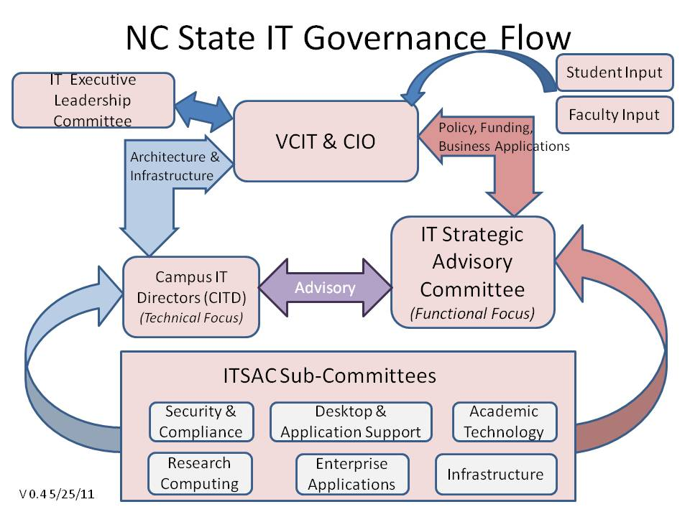

APPENDIX A – GOVERNANCE STRUCTURES (continued)

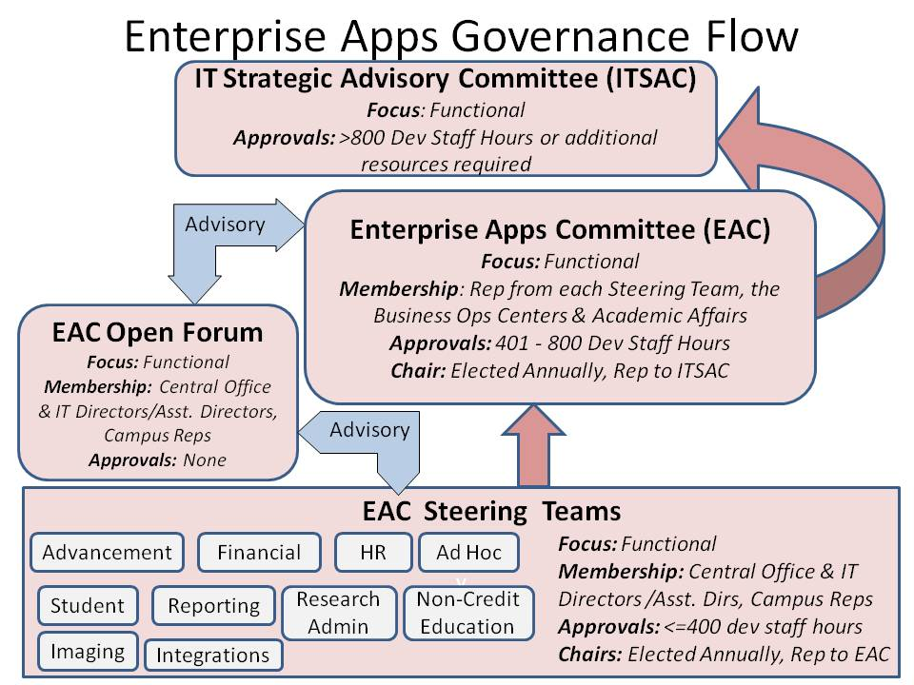
APPENDIX B - MEMBERSHIP
Area member represents | Position | Name | Voting Member?
Advancement Systems Steering Team | Chair’s Designate | Kushal Dasgupta | Yes
Business Operations Centers |  | Don Patty | Yes
Financial Systems Steering Team | Chair | Charles Cansler | Yes
HR Systems Steering Team | Chair | Brian Simet | Yes
Imaging Systems Steering Team | Chair | TBD | Yes
Integrations Steering Team | Chair | Barbara Moses | Yes
Non-Credit Educational Systems Steering Team | Chair | Alice Warren | Yes
Office of Information Technology | Director, EAS | Gwen Hazlehurst | Yes
Reporting Systems Steering Team | Chair | TBD | Yes
Research Administration Steering Team | Chair | Rick Liston | Yes
Student Information Systems Steering Team | Chair | Michelle Johnson | Yes
Academic Affairs | Asst. Dean for Academic Affairs, CHASS | Karen Young | Yes
 | NON-VOTING_
Internal Audit | Asst. Director | Leo Howell | No
Security and Compliance | Director | Mardecia Bell | No
Technology Support Services | Director | Susan Klein | No

APPENDIX C - BASICS OF ROBERT’S RULES OF ORDER

General Order of Meetings
1. Call to Order
2. Approval of Previous Meeting’s Minutes
3. Special Presentations and Reports
4. Unfinished (Old) Business
5. New Business (including Change Requests which require a motion for approval)
6. Adjournment

Procedure to Make a Motion
1. Member states the motion. e.g. "I move that we ___________."
2. Member may give a brief explanation for introducing the motion.
3. Another member must second the motion to continue.
4. Presiding officer calls for discussion on this motion. The member who introduced the motion has the right to speak first. Members wishing to discuss the motion raise their hands and wait for recognition from the presiding officer before speaking, enabling everyone to share opinions.
5. Presiding officer calls for a vote on the motion.
6. Presiding officer states results of vote and resulting action.

Members may "call the question" to end discussion on the motion if discussion seems to be dragging on or becoming redundant; however, it is NOT acceptable to call the question in order to prevent someone from expressing his opinion or while someone is speaking. If a member calls the question, a second and a 2/3 majority vote are required (no discussion) to close discussion and proceed to voting on the motion.

Procedure to Amend a Motion
During discussion, it may become apparent that an amendment (modification) to the original motion is necessary. Anyone may request to amend the original motion, but the proposed amendment must be related to the subject of the main motion.

1. Member states the amendment (e.g. striking and/or adding words/phrases).
2. Amendment must be seconded.
3. Presiding officer calls for discussion on the amendment.
4. Presiding officer calls for a vote on the amendment, and announces result.

If the amendment passes, the motion on the floor is now the amended motion. If the amendment fails, the original motion remains on the floor.

