Financial 9.1 Upgrade

Status Update as of December 9, 2011

Overview
The Financial 9.1 Upgrade is progressing well and the team is on schedule to meet the target go-live date of March 26, 2012. For general information on the upgrade, including the project timeline, please refer to the following URL: http://www7.acs.ncsu.edu/FinTraining/FocusGroup/
On November 15, 2011, the upgrade entered into the campus customer testing phase of this project. The 9.1 Project Team that includes all members from the EAS Financial Team and strong representatives from our Central Offices (Budget Office, Contracts and Grants, Controller’s Office, Foundations Accounting & Investments, and the Purchasing Department) were joined by eighty-four (84) campus volunteers that have been involved (or will be involved) in testing various critical components of the new Financial System utilizing a test system integrated through a test copy of the MyPack Portal. Most of the campus testing sessions will be completed by December 23, 2011, though the Asset Management and Surplus testing phases have been rescheduled for mid-January, 2012. In addition, select campus testers that participated in the Small Purchase Voucher Testing phase may be asked to return in early January, to perform finalized testing for several code changes that are still in progress. Listed below, you will find:
- Summary of the Testing Groups and Issues noted as of December 9, 2011
- Status Update by module from an EAS Financial Manager perspective of where each of the Financial 9.1 modules stand as of December 9, 2011 from a campus and central office testing perspective;
- Overview of Next Steps that will occur after December 2011.

Summary of Testing Groups and Issues
The Campus Testing portion of the Financial 9.1 Upgrade has been divided into twelve (12) Groups as follows:
- A: MarketPlace Entry / Receiver Entry / Wolfpack Reporting System
- B: Requisition Entry / Receiver Entry
- C: Small Purchase Voucher Entry / Vendor Request Entry / Wolfpack Reporting System
- D: Travel Authorization and Travel Reimbursement Entry
- E: PCard Reconciliation / PCard Request / Wolfpack Reporting System
- F: Project Attribute Entry (Group Cancelled)
- G: Bill Entry
- H: Grant Close-out
- I: Chartfield Request
- J: IDT Entry / Wolfpack Reporting System
- K: Journal Entry / Wolfpack Reporting System
- L: Asset Maintenance / Surplus Request
One Group (Group F: Project Attribute Entry) was cancelled based on need/impact of changes not being significant as a result of the 9.1 Upgrade. As of December 9, 2011, nine (9) have either completed testing or are in the process of testing and have reported 188 items. A summary of these issues are listed below separated by status (EAS Researching-29, Not an Issue-64, To Be Fixed for Go-Live-28, Fixed-55, Enhancement/Prioritize After Go-Live-12).
Figure 1: Summary of Issues by Status/Group
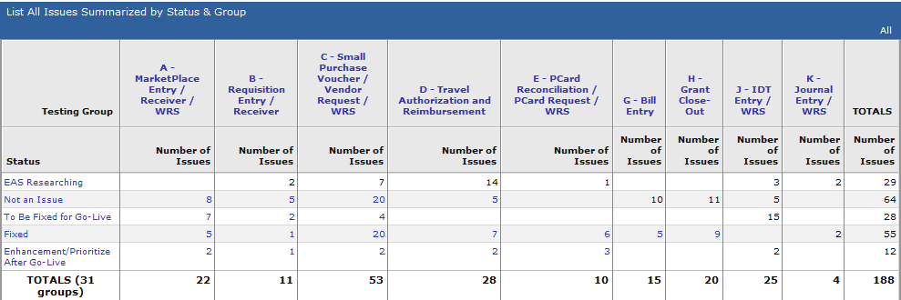

Status Update By Module
The following status update is a high level summary by module (or Bolt-On) which is a custom module created by NC State University. The areas highlighted in this status update are the area’s that have the greatest impact on campus customers. All Central Offices are actively engaged in testing and verifying that their core processes are working with the Financial 9.1 Upgrade. In general the campus testing portion of the project will be completed by December 23, 2011. This excludes Asset Management / Surplus Testing. In addition due to the large campus usage of small purchase vouchers, a select group of campus testers may be asked to return in January to complete final validation of a few issues that are being corrected currently.
Overall the testing is going extremely well. The Status section below is a high level evaluation from EAS on risk assessment as of December 9, 2011. Once testing is finalized and the Central Office provide formal sign-off for their respective modules, we expect to see all of these items move into a Complete Status by the end of January, 2012.

Module / Area | Status* | Campus Testing Status | Central Office Status
Accounts Payable | Good | Scheduled sessions complete. May ask select campus customers to return for final validation after code changes are complete. | Controller’s Office is nearing completion of testing. Retesting as issues requiring code changes are complete.
Accounts Receivable | Good | N/A | C&G & Controller’s Office Completing Final Testing
Asset Management / Surplus | Watch | Campus Testing Rescheduled for January 11/18. | AM Conversion-Controller’s Office validating. Interface testing with Vouchers/Requisitions still needed. Surplus conversion is pending. All other Central Office testing (Controller’s Office for AM / Materials Management for surplus) is Completing Final Testing.
Billing | Good | Complete (All Items Corrected) | C&G & Controller’s Office Completing Final Testing
Capital Improvement  (Bolt-On) | Good | N/A | Facilities & Budget Office Completing Final Testing
ePro (MarketPlace) | Good | Complete (Final review of issues pending) | Complete (Pending final review of issues)
General Ledger
- Chartfield Request (BO) | Good | Scheduled to begin 12/12. | All Central Offices Completing Final Testing
- IDT (BO) | Good | In Progress (first session was 12/8)
- Journal Entry | Good | Rescheduled to begin 12/13 | EAS Testing being finalized. Will release to Campus/Central Offices 12/13.
- Project Attributes (BO) | Good | N/A | All Central Offices Completing Final Testing
Grant Close-out (Bolt-On) | Good | Complete (All Items Corrected) | C&G Completing Final Testing
PCard |  | Campus Testing in process. | Materials Management will retest certain area’s as issues that require code changes are completed.
Portal | Good | In Process (Nearly Complete). EAS will refresh Portal Folder Security to remove some delivered folders that no longer display content due to navigation improvements. | All Central Offices will need to verify all content is displayed correctly in the Portal as they complete testing.
Purchasing (Requisitions) | Good | Complete | Complete pending fix from PeopleSoft to allow more than 30 lines on requisition. Pending final review of issues.
Reporting
- Endowment | Good | N/A | FAI-Finalizing Testing
- Foundations | Good |  | FAI-Finalizing Testing
- CI/Perl | Good |  | Facilities & Budget Finalizing Testing
- WRS | Complete | Complete | Complete
- Trial Balance | Good | N/A | Controller’s Office Finalizing Testing (retesting needed after Asset Ledger conversion. Note, EAS is configuring security to enable web access to nVision
Travel (Bolt-On) | Good | Complete | Controller’s Office and EAS reviewing issues log to determine action required.

Next Steps (Overview)
The following is a list of next steps that will occur for the Financial 9.1 Upgrade. Coordination for these steps is expected to occur in December/January.
- CENTRAL OFFICE SIGN-OFF. All Central Offices will be asked to formalize their respective modules. This includes a confirmation that the customizations made to the modules meet expectations and are approved.
- TRAINING PREPARATION. We need to finalize the training plan. This includes updating existing training documentation and online material (UPK Online Training). Note that Tom is researching status of an upgrade to the UPK software that is used to create the online training.
- PERFORMANCE / LOAD-TESTING. Continue and complete the performance testing that is running against hardware that has been created as the Financial 9.1 Production System. Note that this is new hardware that replaces the servers that are currently run the Financial 8.9 System.
- DETAILED SECURITY REVIEW. Detailed security review of the following five area’s:
  - Special ID Access and Certification
  - Correction Mode Review and Approval
  - Campus Role/Permission List Review and Approval
  - Central Office Role/Permission List Review (note, special review will be conducted to certify all users assigned to Central Office Roles)
  - Developer Role/Permission List Review and Approval
- CERTIFY DEPARTMENT WORKFLOW SETUP. Workflow changes were significant with the Financial 9.1 Upgrade. Changes were made in version 8.9 to capture the desired approves and this workflow is being tested in Financial 9.1. Due to potential of confusion we need to heavily communicate these changes and obtain specific certification that the setup at the College/Department level is complete, approved, and communicated to all impacted parties.
- COMPLETE DETAILED GO-LIVE PLAN. This plan will include the detailed steps required and timing necessary for the upgrade (and any downtime and verification needed). In addition these steps will need to detail out the steps, timing and communication necessary for active transactions that have been initiated in the Financial 8.9 System and are still in process at time of upgrade).

