Infrastructure Technologies Advisory Group
Notes

April 2, 2020

Present: Dan Deter, Keith Boswell, Greg James, Chris Allen, Greg Sparks, Vijay Taylor, Debbie Carraway, Aaron Peeler, Andy Kotynski, David Ladrie, Joe McCoy, Doug Flowers, Dustin Duckwall, Ed Rogers, Eric Sills, Franklin Finch, Gary Li, Mark Williams, Tony Copeland, Pat Gaddy, Josh Jury, Chris Eichman, Kevin Lee

Welcome

Reminder: Google group… group-intag@ncsu.edu

Staffing Update
- New LAN engineer position

COVID-19 Impact
- Minimizing staff on-site while maximizing services offered - very few impacts and fully supporting all existing services
- Working to move to business hours support for most buildings realizing some critical buildings will need 24/7. Will share list with CITD next week for input.

Campus Network
- Current firewall project is the site to site hardware upgrade - Site migrations have started and will continue for the next few months
- Developing a solution for remote site connectivity outside of Wake County - no new updates or testing on this
- Now focusing on core firewall upgrade - testing in the lab has begun with Palo Alto - working with S&C to discuss IPS options
- Next generation edge switches - sticking with Cisco - new architecture will be discussed at LAN Admin meeting - will cost for port activations go down? Yes, $100/per port starting on July 1
- Testing new Internet gateway equipment for future implementation - Nexus 9336, successfully implemented, will need to schedule other gateway in the future
- Cisco VPN Anyconnect upgrade - Completed
- Backbone updates - Investigating requirements and implementation standards
- Life Safety Centrex Replacement
  - NMDF and SMDF zones - 1st cutover being scheduled
  - CMDF - construction in progress
- Redundant fiber entrances - SMDF zone - installing racks, eqpt.
- Hillsborough St. crossings - Approved by City Council, Real Estate trying to determine next step

Access Layer
- TUNAMELT project - 3560x switches - designs completed (26%)

Data Center
- DC1 Decommissioning
  - VM migrations are going well. Less than 80 vms remain in general clusters.
  - EDC - working on phase 2 infrastructure
- DC2 Elec/Mech upgrade - design started
- General service offering for colo - Summer
  - Poe tenants early access (likely May timeframe but shout if immediate need)
  - Intake processes being refined
  - Cost model for rack space being finalized - current draft - these costs will hold through June 2021
  - Special challenges of tape libraries - need to change tapes on a regular basis, etc
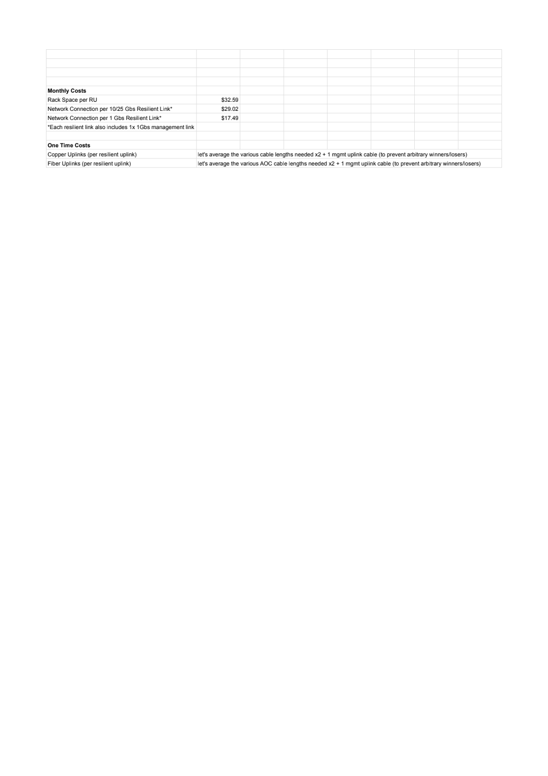

CATV
- Working with Apogee on streaming/CATV combo for 20/21 school year.

MDFs
- NMDF - design in progress elec/mech upgrade.
- Lake Wheeler MDF - to be reviewed by Space Committee next week

Infrastructure Records
- Outside plant inventory project in progress

Building Infrastructure Projects
- Design – Sigma Kappa, Zeta Tau Alpha, Alpha Delta Pi, Carmichael
- Construction – Dabney, DH Hill Academic Success, Kappa Alpha Theta, West Dunn, Materials Mgmt., Sigma Kappa, Harris
- Substantial Completion - Partners 2, EH&S, Polk
- UPS RFP - under review at Purchasing

Cellular/mobile
- Indoor - Spidercloud - Verizon certifying Talley almost done. Next group in negotiation with new VZW team
  - List: SpiderCloud

IT Strategic Planning
- Mostly in a hold pattern awaiting next University Strategic Plan - have started a lessons learned document
- Service Planning
  - CMDB - discovery process is ramping up
  - Considering when to implement Event Management
  - Planning for Change Management moving along well

Unified Communications
- Investigation options for spam blocking and text messaging
- Renewing Cisco EA, possibly with other schools for bulk pricing
  - Working with other schools on group EA renewal
- Partner Updates: UNCG, App State, NC A&T, Pembroke
  - Supporting call centers
  - Rolling out remote work tools at all schools
  - Rolling out Expressway at App State
- NC DIT -- Tools, Training, Support
  - Supporting cuts
- Life Safety rollout
  - Planning to continue project in current environment
- Phone replacement of 6900, 7900 series phones
  - softphone only option for certain users?
    - Low volume callers
    - Softphone by default but option to come get a phone and self deploy if a handset is desired
  - Any legal requirement for a phone in office/hallway/etc?

Systems & Development
- Tools Updates
  - Moving to Docker Containers
  - Eduroam with AD Certificates / Radius
    - Working on Mac integration
  - Service Now Integration
    - Automated incidents for audit tracking
- Thresholds and Alerts
- Mobile management tool for Life Safety lines
  - Adding Fire Alarm Dialers to database
  - BAM Integration
- Pulling outside plant copper into EPIC

Wireless
- Wi-Fi 6 Project - Priority list WI-Fi 6 ballot, funding model discussion
- King Village wireless - summer 2020
- Classroom wireless: 210 classrooms list mostly complete - will need to determine funding 170 rooms - $238,000
- Outdoor Wireless: working on Wi-Fi pole model
- EDUROAM (secure SSID) -
  - Wifi.ncsu.edu is now live with links to SecureW2 for eduroam
  - AD certs - Have finally got them working. Will discuss at LAN Admin meeting
- Now tracking wireless metrics as part of overall monthly metrics
  - Note - Airwave continues to have issues, will begin testing the Aruba appliance this week or next
- Look at practicality of loaning out to departmental staff - No movement on testing more handheld devices

Storage Infrastructure
- NAS Migration
  - On-track to decommission DC1 NAS arrays in March. -- Delayed due to covid-19, MFDs have to be updated to scan docs to new share
- Research storage allocation methodology is changing:
  - 2TB per faculty researcher standard offering
  - Allocations for awarded grants based on grant requirement and retention based on data management plan - so far as practicable will not charge.. however, beyond some amount there will have to be some cost recovery - hopefully will be clear ‘unlike circumstance’ and be able to pay from direct grant funds
- Proposal being forwarded to ORI for some additional research storage resources; increased curation support from Libraries, additional security analyst, additional systems position for storage refresh in 2021 (would also provide backup to HPC systems position)
- AFS to AuriStor - Database migration from EOS to AuriStor is complete. Most of the file server and volume migrations are also complete. Reached out to Delta about the legacy volumes on Wolfware servers. Also working on cleaning up references to the old BP cell.

Server Infrastructure
- Funding received(and HW ordered) for DC2 storage growth and compute refresh.
  - DC2 U650F growth
  - DC2 Core cluster storage -- UnityXT 480F
  - 4 x MX7000 chassis and 28 MX740C sleds
Software Infrastructure
- Microsoft VDA site license expires May 31, 2020 - VDA(Virtual Desktop Access)
  - Microsoft extended for VCL only until 8/31/2020 due to covid-19
  - Software Lic. FAQ
  - Original sysnews post
  - VCL FAQ
  - VCL - Azure Windows Virtual Desktop (WVD)
    - OIT PCS/WMS teams scheduling meetings and demo’s
    - What’s the impact of using Adobe products in WVD?
  - VDA dependency outside of VCL - Student RDP into research or lab machines.
  - This Google sheet was created to get an estimate on the overall VDA license need on campus.
  - Colleges will go through OIT Software Licensing to get individual VDA license (and ensure compliance) after that. More information is provided by Software team in FAQ
- RedHat License
  - Seriously investigating if can drop Red Hat license in 1-2 years
  - Did not join the System Office license, would have required renegociation with Red Hat (and then if we do drop the license another disruption for them in a year or two)
  - Planning to renew just the OS license (previously we had “Infrastructure” license), so far as we can determine no one is using any of the infrastructure features - satellite is bundled in both options now.
  - Leaning toward changing to regular vs premium support. Business day vs weekend/after hours.
  - Also, expect that will be working to register systems upstream and eliminate the campus satellite (all the issues OIT has logged with Red Hat have been regarding satellite)

Governance Revamp

Still need to figure out future of ITSAC-I and any relationship to this group
  - Quarterly?? More of a ComEx?
  - Where do folks go for IWS?? Relationship to infrastructure…
  - Sounds like there could still be a gap around sharing/discussion of general infrastructure initiatives beyond OIT

Budget
- Reminder: Centrex lines are now being billed to departments at actual cost - have shared a list of lines with CITD. Current contract ends December 2020 and prices are expected to rise to at least $40/line/month. Working to migrate lines ahead of that unless technical/compliance constraints.

Parking Lot Items
- Routing licenses at the BDF level – when and how much should occupants pay? Interim solution is 50/50 when “desired”, ComTech funds when required
- “virtual data center” – 4/5/18 conversation confirms there’s still some need for “flat” networks (even outside the data center)

Upcoming Meeting Dates
- Next InTAG Meeting – May 7, 2020

